**8 BIT MULTIPLICATION**

**EXPERIMENT 3**

**AIM:** To write an assembly language program to implement 8-bit multiplication using 8085 processor.

**ALGORITHM:**

1. Start the program by loading HL register pair with address of memory location.  
2. Move the data to a B register.  
3. Get the second data and load into Accumulator.  
4. Add the two register contents.  
5. Check for carry.  
6. Increment the value of carry.  
7. Check whether repeated addition is over and store the value of product and carry in memory location.  
8. Terminate the program.

**PROGRAM:**

LDA 8500

MOV B,A

LDA 8501

MOV C,A

CPI 00

JZ LOOP

XRA A

LOOP1: ADD B

DCR C

JZ LOOP

JMP LOOP1

LOOP: STA 8502

RST 1

**INPUT:**

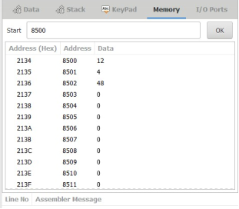

**OUTPUT:**

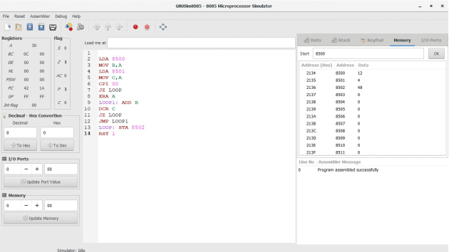

**RESULT:** Thus the program was executed successfully using 8085 processor simulator.